SIMATS ENGINEERING
CO3-ASSESSMENT TOOL 2

COURSE NAME: ANALOG CIRCUIT S COURSE CODE: ECA04

COURSE OUTCOME COVERED
CO3: Examine the frequency response characteristics of BJT and FET amplifiers at low
and high frequencies to determine bandwidth, gain variation, and overall amplifier
performance (BTL 2,3, 4), (WK1,WK2,WK3,WK4)
Assessment Tool number : AT2
Assessment Tool Weightage : 35%
Assessment Tool Name : Circuit Debugging
Duration of this assessment : 90 Minutes Marks : 20
Type of Assessment conduction : Inside Class
Evaluation Type : Manual Correction
Description:
● Each student will be assigned one Circuit debugging problem 20 marks inside
class. Analyze and debug one faulty analog circuit.
● Simulate the corrected circuit using LTspice and verify results.
● Document the debugging process, observations, and conclusions.
● Upload LTspice files, simulation results, and report to GitHub.
● Evaluation is based on fault identification, debugging approach, simulation
accuracy, documentation, and GitHub submission.

Topics Covered In this assessment:
General shape of frequency response of amplifiers - Low frequency analysis of BJT/ FET
amplifiers to obtain Lower cut off frequency - High frequency analysis of BJT amplifiers to
obtain Upper cut off frequency- rise time and sag and their relation to cut off frequencies-
High frequency analysis of FET amplifiers- High frequency equivalent circuit of FETs.

(8th) During Transient Analysis with a 10 mV, 1 kHz sinusoidal input, the output waveform is highly attenuated although the transistor remains in the active region. Debug the circuit using LTspice, identify the faulty passive component, implement the correction, and verify the restored output waveform.
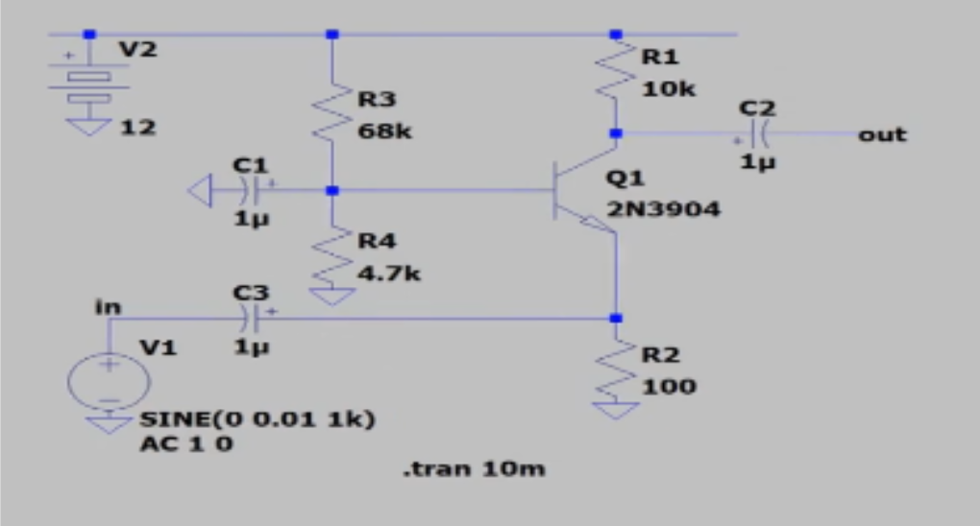
OUTPUT:
